Yasser Mimouni, Imam Bakadour, Samir Elkanouni

encadré par:  Mr. EL Bahir

energie Éolienne

# ABSTRACT

In the context of the seminar part of our 4th year in the national school of applied science, and as (future) embedded systems and control systems engineers, it is essential to have the knowledge required to control, study and maintain a wind powered turbine/plant. As such, this report is a testimony to our findings in this field.

In this report, we will explore the inner workings of wind turbines, their main components, the equations describing their functioning principles.

We will also be talking about the electronics side such as the sensors, the pre-actioners and the actioners permitting such an engineering marvel to function properly.

# TABLE OF CONTENT

# INTRODUCTION

To start our report, we must cite why wind energy is such an important topic; as such, we will be citing some statistics that clearly state how important such a technology is:

* According to an [article on Atalayar.com](https://www.atalayar.com/en/articulo/economy-and-business/morocco-generates-enough-wind-power-cover-its-needs-17-times-over/20220609154950156826.html):
  + Morocco generates enough wind power to cover its needs 17 times over in 2022.
  + Morocco has been among the world's 30 leading countries in the offshore wind market.
  + The strategy aims to gradually increase national wind power production, starting with 1GW by 2024 and up to 4.2GW by 2030.
* According to a [study paper in ScienceDirect.com](https://www.sciencedirect.com/science/article/pii/S2405844018374474) published in 2018:
  + In particular, Morocco has good climatic and geographic conditions for installation wind turbines with 17 selected regions for their use in wind power generation
  + Morocco has 3500 km of coastline, which mean wind speeds can reach up to 10 m/s. Therefore, the estimated total theoretical potential of wind power in Morocco is 25 GW
* According to TheWindPower.net website:
  + As of 2022, morocco has an installed capacity of 1556 MW
  + This is an increase of 8.5% with respect to 2021
  + The total installed capacity has been steadily rising since 1997

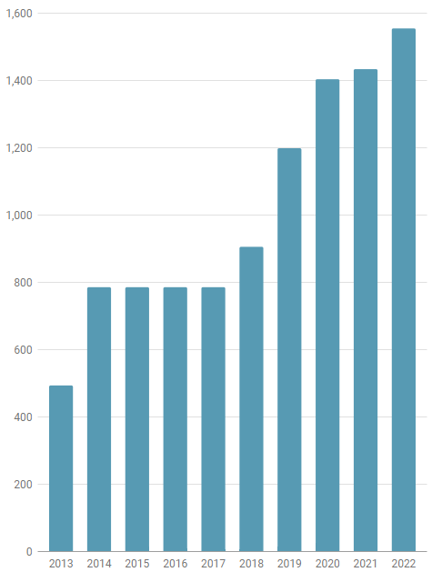

Fig: total installed capacity in morocco (2013 – 2022)

* According to the same source, there are 25 farms, of which two are under construction. A total of 844 turbines.

We have actually had the chance to visit “AMOUGDOL”, the wind farm located near essaouira.

With The importance of wind power clearly outlined, we can move on to detailing the more technical aspect of typical wind turbines.

# WORKING PRINCIPLES

The two main types of wind turbines are:

1. Horizontal-axis wind turbines (HAWTs),
2. Vertical-axis wind turbines (VAWTs).

There are wind turbines (either HAWTs or VARTS) with two or three blades; in this report, we will cover the most widely used: the HAWTs with three blades. A standard turbine is around 141 meters tall.

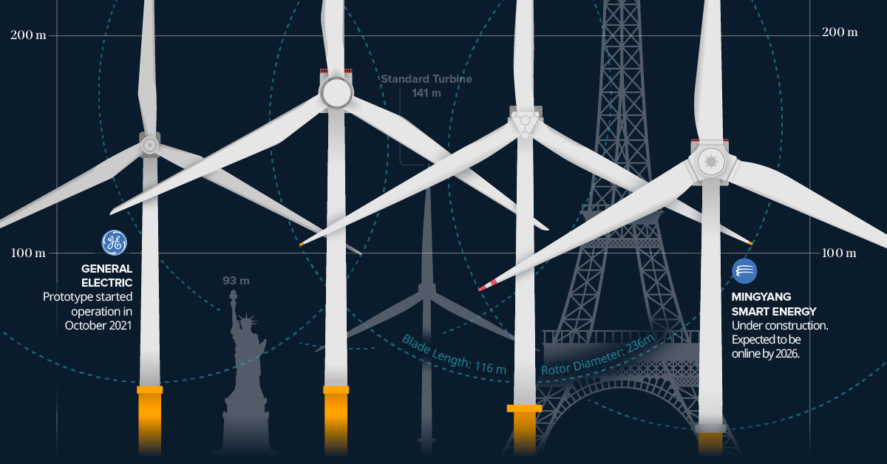

Fig: 3-bladed HAWTs

The height allows the turbine to take advantage of the high wind speeds in higher elevations. There speeds influence directly the speed, and thus the power generated, of the blades, we will discuss this more in the next section.

The hub of the turbine, that is the housing attached directly to the top of the tower, contains the bulk of the power generating elements:

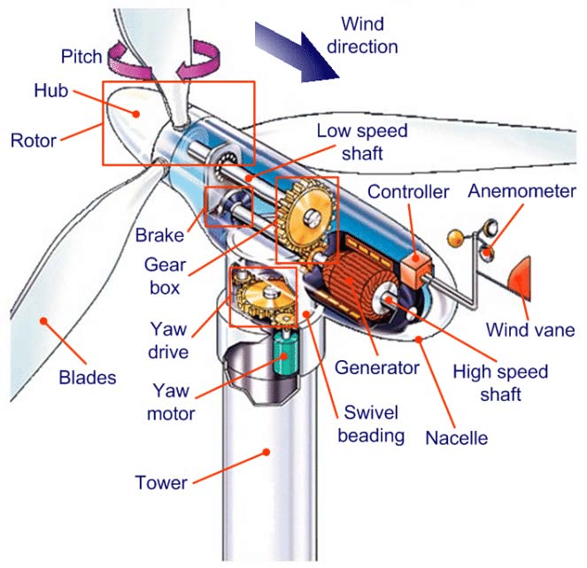

Fig: inside view of the hub

As the wind direction is anti-parallel to the axis, the blades need to be at an angle to achieve sufficient drag that allow the rotor to spin. This is achieved through the pitch control, this also has the benefit of controlling the rotation speed since it is affected by the area hit by wind, and this is nicely described by the following equation:

$$P =\frac{1}{2} Cp ρ π R^{2}V^{3}$$

Where:

* + - * P: power generated (W)
      * Cp: a measure of the aerodynamic efficiency of the turbine this coefficient is highly dependent on the pitch of the blades as well as the general geometry of the turbine.
      * $ρ$: air density (pretty much constant)(km/m3)
      * R: blade length (m)
      * V: wind speed (m/s)

The formula above shows that the power output of a wind turbine is a ***cube function*** of incoming wind velocity. It also showed that the potential power generation of a wind turbine is a square function of its blade length.